Deadline for submittal: 2:00PM (1:00PM Alaska) – Monday, June 6, 2022
SCHOLARSHIP APPLICATION
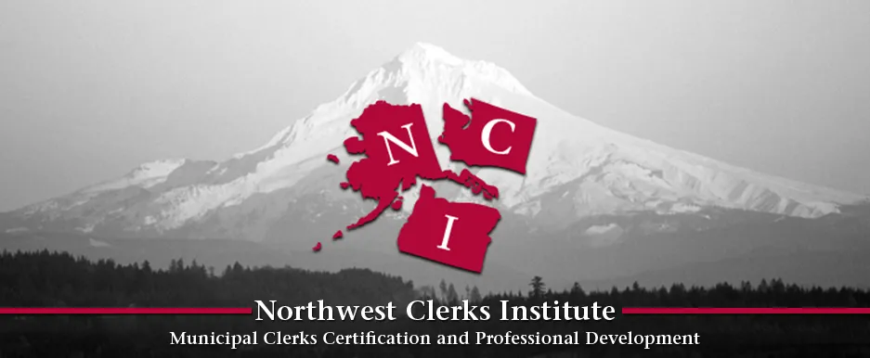Please complete all sections of the application

Name: Email:

Employer: Job Title:

Employer Address:

Are you a Member of WMCA _____ OAMR______ AAMC_______ (check one)
Are you currently a member of IIMC? Yes No
Which of the following events are you applying for a scholarship to?
Note: For PDII, PDIII, or PDIV you may apply for a scholarship for registration OR housing (select one below)
Northwest Clerks Institute (NCI) Professional Development 2 (registration only)
Northwest Clerks Institute (NCI) Professional Development 2 (base housing on campus)
Northwest Clerks Institute (NCI) Professional Development 3 (registration only)
Northwest Clerks Institute (NCI) Professional Development 3 (base housing on campus)
Northwest Clerks Institute (NCI) Professional Development 4 (registration only)
Northwest Clerks Institute (NCI) Professional Development 4 (base housing on campus)

I have attained confirmation that my entity will support this training, as required.

I understand and agree that I will need to complete the requirements of the scholarship award including full attendance at the event, completion of a KTAP (if applicable.

Signature: Date submitted:

Please submit the completed application materials by email to:
Joann Tilton
NCI Director
nwcidirector@gmail.com
For additional information or questions, please call 209-456-7855.

Deadline for submittal is 2:00PM (1:00PM Alaska) – Monday, June 6, 2022 - Late applications will not be considered.

